|  |  |
| --- | --- |
|  | |
| Microsoft Planner Custom Activities | |
| UiPath Hackathon | |
|  | |
| Version: 1.0 |  |
|  |
| 2020-04-20 |

Table of Contents

1 Introduction 3

2 Prerequisites 4

2.1 Office 365 Account 4

2.2 Azure App registration 4

2.3 Planner information 6

3 Activities 7

3.1 Planner Scope 7

3.2 Plan Activities 7

3.3 Bucket Activities 7

3.4 Task Activities 7

3.5 Group and User 7

3.6 Conversation 7

4 Microsoft Documentation 8

# Introduction

This document is made to document how to use the Microsoft Planner activities made during the UiPath Custom Activities hackathon 2020. This includes the Perquisites, Activities and links to relevant Microsoft documentation.

# Prerequisites

This package is built by using the Microsoft graph API, which can be used to interact with planner if the user has the right permission. There are some perquisites to using Microsoft graph API, which is listed in this section

## Office 365 Account

Microsoft graph API only supports user authentication when interacting with Planner, an office 365 account with access to the planner is therefore required in order to authenticate when utilizing the graph API.

## Azure App registration

1. Create app registration in azure and follow the steps described below.
2. In the Authentication tab, the following options must be checked:
   1. Add platform -> choose Mobile and desktop applications - > Custom redirect Uri -> type a custom URI or use a default one -> Note it down for later use.
   2. Default client type -> Set it to yes Treat application as a public client is set to Yes

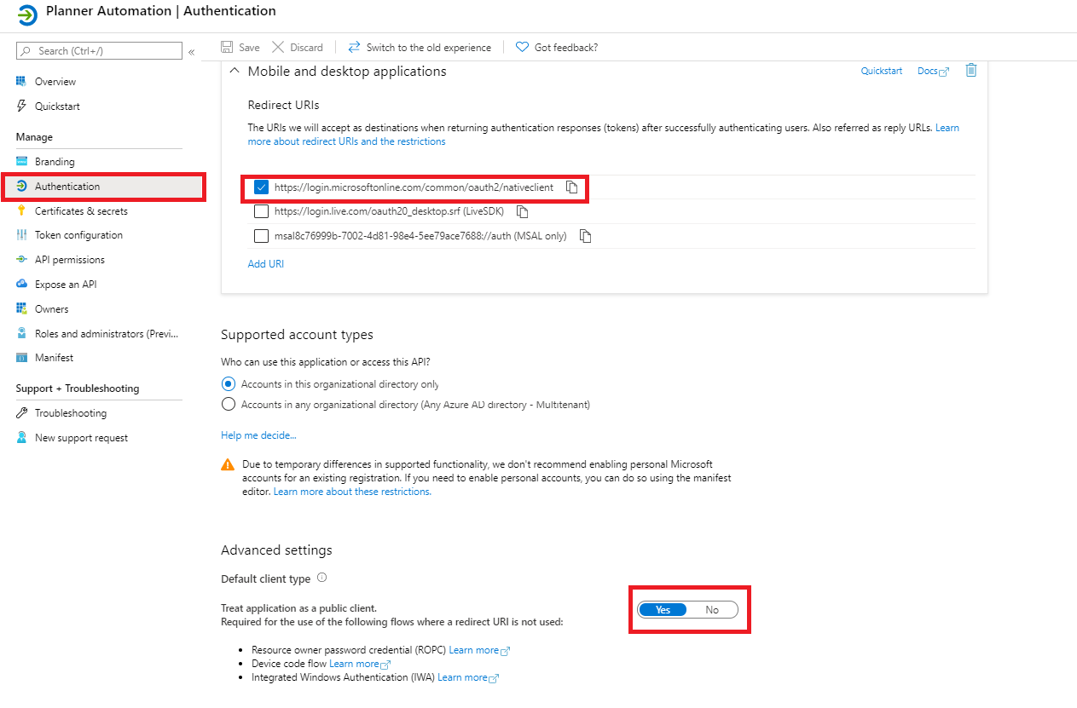

Figure 1 – Authentication Tab

1. In the API permissions tab, the following permissions needs to be checked:
   1. User.read,
   2. User.Read.All
   3. Group.Read.All
   4. Group.ReadWrite.All.
2. The permissions need to have granted admin consent which can be done by a admin by clicking grant admin consent for organization.

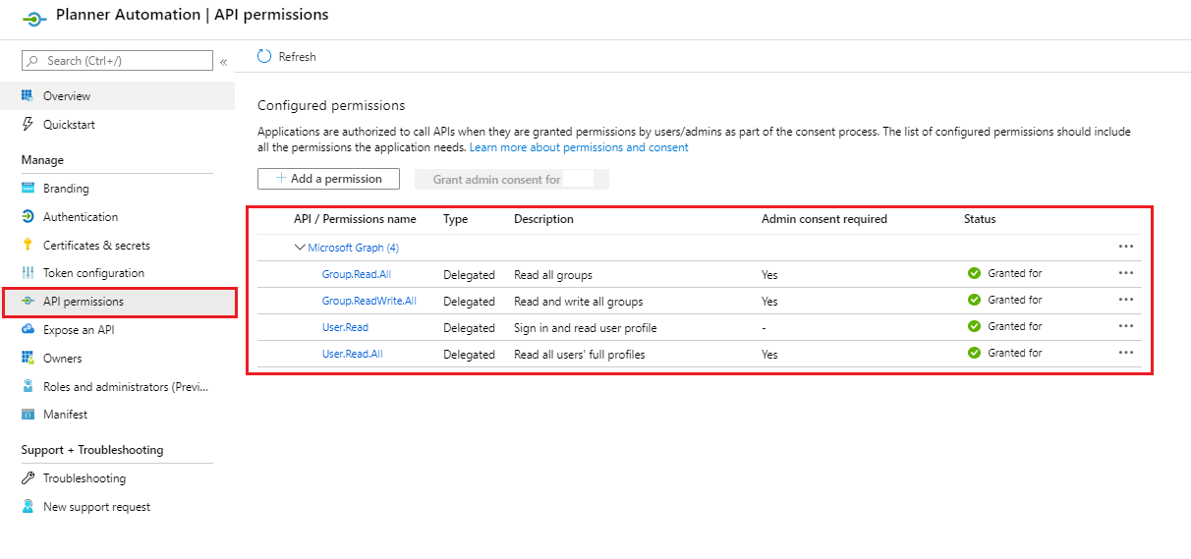

Figure 2 – API Permissions Tab

1. Redirect URI seen in step 2 is used along with ClientId and TenantId as input parameters for the planner scope. The ClientId and TeantId can be found on the overview page.

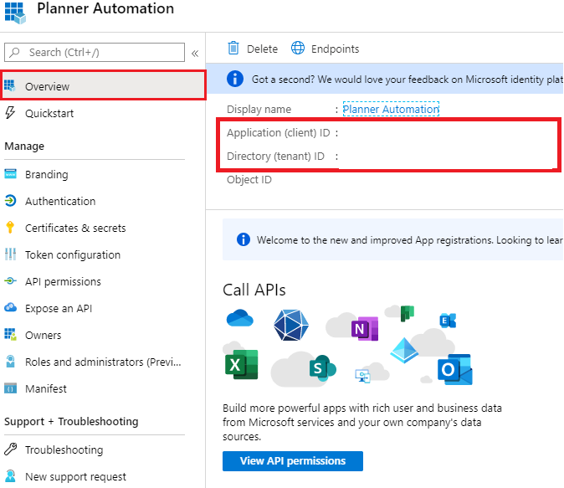

Figure 3 – Overview Tab

## Planner information

When querying the Graph API, the Plannerid and the Groupid is needed. It can be found in the planner URL when you access the planner in your preferred browser.



Figure 4 – Planner URL

# Activities

This section describes the activities briefly and highlight the most important ones. To find more information about the individual possibilities with each check the descriptions in UiPath or lookup the Microsoft documentation seen in section 4.

## Planner Scope

|  |  |  |  |
| --- | --- | --- | --- |
| **#** | **Name** | **Description** | **Required arguments** |
| 1 | Planner Scope | The scope that authenticates against the azure AD for all activities inside. | Authentication Type  ClientId (see 2.2 step 5)  TenantId (see 2.2 step 5)  RedirectURI(see 2.2 step 2b)  Username - when using credential authentication.  String - Password when using credential authentication. |

Table 1 – Planner Scope

### Authentication Types Enum

|  |  |
| --- | --- |
| **Name** | **Description** |
| Integrated Window Authentication | Unattended authentication with windows integration, if it cannot login with windows it defaults to attended interactive authentication. |
| Credential Authentication | Unattended authenticate with username and password |
| Interactive Authentication | Attended authentication with an interactive session |

Table 2 – Authentication Enums

## Plan Activities

|  |  |  |  |
| --- | --- | --- | --- |
| **#** | **Name** | **Description** | **Required Arguments** |
| 2 | Get All Buckets in Plan | Get all buckets in a plan | PlanId (see 2.3) |
| 3 | Get All Tasks in Plan | Get all tasks in a plan | PlanId (see 2.3) |
| 4 | Get Plan | Get plan properties and relationships | PlanId (see 2.3) |
| 5 | Get Plan Details | Get task details like CategoryDescriptions and SharedWith by using plan id | PlanId (see 2.3) |
| 6 | Get Planner Group | Used to get group details related to planner | GroupId (see 2.3) |
| 7 | Update Plan | Update plan with basic information | PlanId  One of the input fields or format your own json |
| 8 | Update Plan Details | Update plan details | PlanId  One of the input fields or format your own json |

Table 3 – Plan Activities

## Bucket Activities

|  |  |  |  |
| --- | --- | --- | --- |
| **#** | **Name** | **Description** | **Required Arguments** |
| 9 | Create Bucket | Creates a new planner bucket | BucketName and PlanId or  format your own json |
| 10 | Delete Bucket | Deletes a planner bucket | BucketId (Can be found with Activity #2 and #9) |
| 11 | Get All Tasks in Bucket | Get all tasks in a bucket by using bucket id | BucketId (Can be found with Activity #2 and #9) |
| 12 | Get Bucket | Get bucket properties and relationships | BucketId (Can be found with Activity #3 and #9) |
| 13 | Update Bucket | Update bucket | BucketId (see 2.3)  Bucket Name or string - jsonformat |

Table 4 – Bucket Activities

## Task Activities

|  |  |  |  |
| --- | --- | --- | --- |
| **#** | **Name** | **Description** | **Required Arguments** |
| 14 | Create Task | Creates a new planner task | PlanId, BucketId, string -Title or  format your own json |
| 15 | Delete Task | Deletes a planner task | TaskId (Can be found with Activity #2, #11 and #14) |
| 16 | Get Task | Get Planner task | TaskId (Can be found with Activity #2, #11 and #14) |
| 17 | Get All My Task | Get all tasks for the signed in user |  |
| 18 | Get Task Details | Get additional information about a task like checklist and description | TaskId (Can be found with Activity #2, #11 and #14) |
| 19 | Update Task | Update plan task | TaskId (Can be found with Activity #2, #11 and #14)  One of the input fields or format your own json |
| 20 | Update Task Details | Update Task details | TaskId (Can be found with Activity #2, #11 and #14)  One of the input fields or format your own json |

Table 5 – Task Activities

## Group and User

|  |  |  |  |
| --- | --- | --- | --- |
| **#** | **Name** | **Description** | **Required Arguments** |
| 21 | Get Plans Related to Group Id | Gets all the plans related to a group Id | GroupId (see 2.3 or use activity #6) |
| 22 | Get User | Get User information | UserId or UserPrincipleName (Emal of the user) |

Table 6 – Group and User

## Conversation

|  |  |  |  |
| --- | --- | --- | --- |
| **#** | **Name** | **Description** | **Required Arguments** |
| 24 | Post Comment to Conversation |  | ConversationThreadId ((Can be found with Activity #3, #11, #16 and #20)  GroupId(see 2.3 or use activity #6)  Comment |

Table 7 - Conversation

# Microsoft Documentation

The overview page of how Microsoft Graph interacts with planner. All the possible interaction is listed on the left side:

<https://docs.microsoft.com/en-us/graph/api/resources/planner-overview?view=graph-rest-1.0>

The Microsoft authentication overview with links to app registrations:

<https://docs.microsoft.com/en-us/graph/auth/>